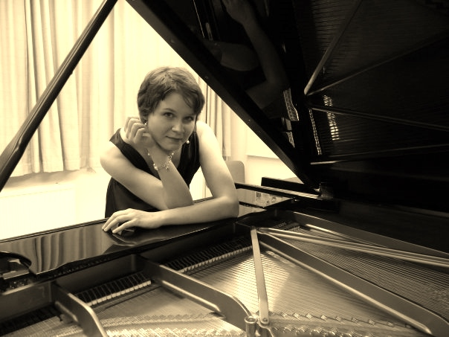
Noora Meriläinen
pianist – piano teacher

Education
2015- Master of music (chamber music), LUCA School of Arts Campus Lemmensinstituut (Belgium)
2013-2015 Master of music (piano), LUCA School of Arts Campus Lemmensinstituut
2008-2012 Bachelor of music education (classical music, specialization in piano), Metropolia University of Applied Sciences (Finland)
Professional experience
Piano teacher in Folk Institute of Tuusula (Finland). Substituting teacher in Music Academy of Lauttasaari, Academy of Keskinen-Uusimaa and Helsinki Conservatory (Finland). Accompanist in Folk Institute of Espoo (Finland). Finalist in Melartin lied competition. Recitals in Finland and in Belgique.
Languages
English, French, Finnish, Swedish

